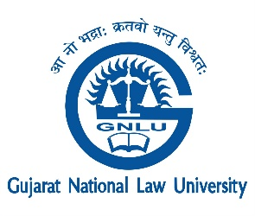

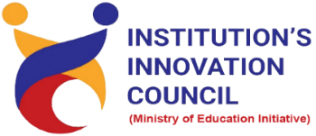
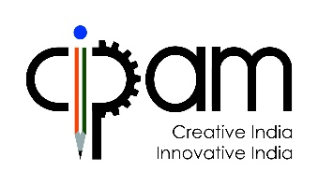
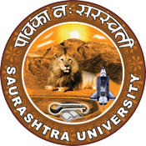

IP Prosecution
12 July 2022
At
Virtually on Webex
Saurashtra University Campus, Rajkot
Contents
Saurashtra University – IIC 2
Event Schedule 2
Event Registration Link 2
Brief about Event 3
Key Points 3
Outcome 3
About the Speaker/Chief Guest 4
Connect Us: 5

Saurashtra University – IIC
The university is dedicated to instruction, research, and extending knowledge to the public (public service). Ministry of Education (MoE), Govt. of India has established ‘MoE’s Innovation Cell (MIC)’ to systematically foster the culture of Innovation among all Higher Education Institutions (HEIs). The primary mandate of MIC is to encourage, inspire and nurture young students by supporting them to work with new ideas and transform them into prototypes while they are informative years. Saurashtra University is one the Organization that have constituted the IIC to foster the vision of MoE and be a part for the promotion and development of innovation ecosystem.

Event Schedule

Event Registration Link

bit.ly/SU-GNLU-IPR

Brief about Event
DPIIT IPR Chair, Gujarat National Law University and Saurashtra University Start-up & Entrepreneurship Council (SUSEC) collaboratively with Cell for IPR Promotion and Management (CIPAM) organized one-day Workshop on "IP Prosecution" on July 12, 2022 Tuesday.
In this webinar discussed about IP Prosecution is encompasses the interaction and negotiation between two parties. Also, what invention can be patented understood by the speaker. In that guideline for IP prosecutor and prerequisites before rejecting a patent application were discussed. It aims to inculcate the spirit of creativity and innovation to students of higher education and ignite and inspire the students of college / Universities to innovate and protect their creations.
Awareness regarding various types of IP Prosecution including Patent, Trademark, Design, Copyright, Integrated Circuit Design and Plant Varieties registration was carried out.
Details, eligibility, how to apply, who can apply and importance of the IP Prosecution was introduced.

Key Points

During the session, below mentioned points were discussed:

- What is IP Prosecution.
- Pre-grant Prosecution.
- What invention can be patented?
- Guidelines for IP prosecutor.
- Prerequisites before rejecting a patent application.
- FAQs related to IP Prosecution was discussed.

Outcome

As per the event, various types of IP Prosecution were understood by the speaker with various examples.
Also, as it was related to Intellectual property and awareness creation, a basic knowledge of intellectual property, how it works, how it can be registered, with various examples etc.

About the Speaker/Chief Guest

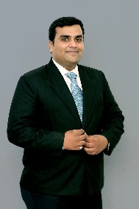

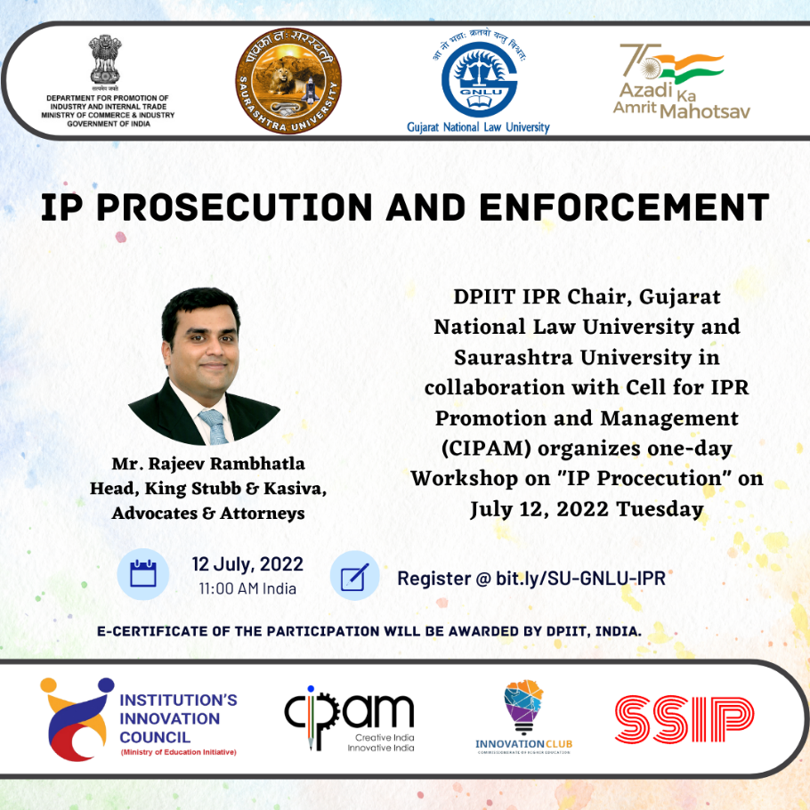
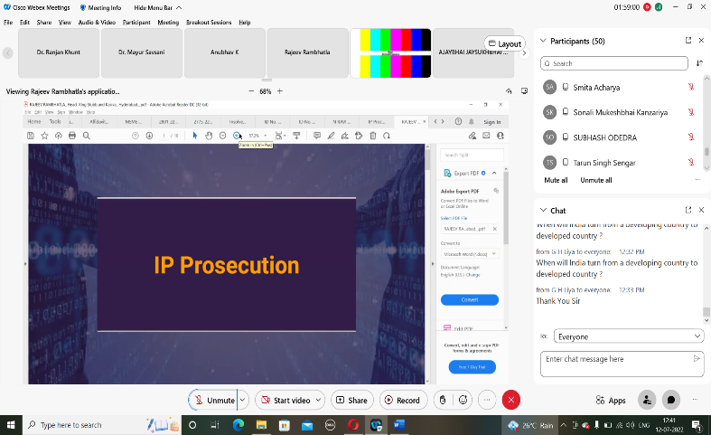

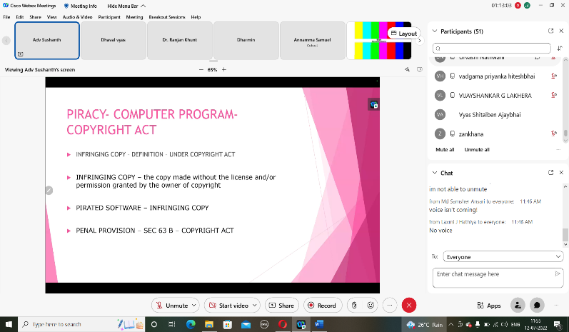
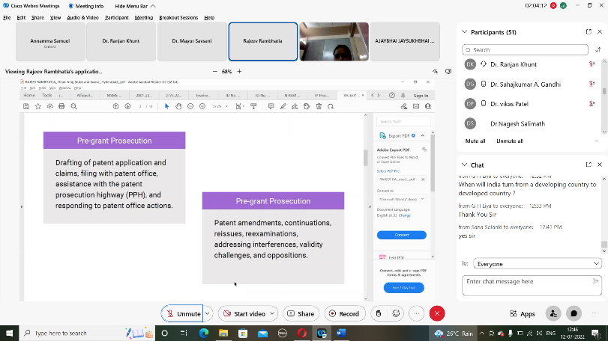

Connect Us:

https://www.linkedin.com/company/susec iic@sauuni.ac.in
https://www.facebook.com/iicsauuni bit.ly/SU-SSIP Location
https://www.instagram.com/susecrajkot https://bit.ly/SUSEC-youtube

